2019
MAES/Parr’s Ridge
STEM Fair Handbook

Table of Contents
What is a STEM Fair? 3
The Scientific Discovery Process 3
Step 1: Your Question 4
Step 2: Design Your Project 4
Step 3: Organize Your Data 4
Step 4: What Did You Learn? 4
Step 5: Where Else Can This Question Go? 4
The Engineering Design Process 5
Step 1: Ask 6
Step 2: Imagine 6
Step 3: Plan 6
Step 4: Create 6
Step 5: Improve 6
The Computer Design Process 6
Step 1: Define a Need 7
Step 2: Research 7
Step 3: Program 7
Step 4: Test 7
Step 5: Redesign 7
Step 6: Conclusion 7
Rules and Regulations: Safety First! Safety First! Safety First! 8
STEM Fair Rules 8
STEM Fair Registration and Fair Day Information 10
How to Register for the Fair 10
On the Day of the Fair 10
STEM Fair Chair and Contact Information 12
Additional Resources 12
Judges Rubric ………………………………………………………………………………………………13-15

What is a STEM Fair?
A STEM Fair is an exciting alternative to the typical Science Fair. This event features Science, Technology, Engineering and Mathematics (STEM) as educational opportunities – showcasing work created by Parr’s Ridge and MAES students.

To get started on your STEM Fair project, you'll learn to observe the world around you and ask questions about the things you observe.
- Get your idea and do some research...
- Ask a testable question…
- Design and conduct your experiment...
- Examine your results...
- Communicate your experiment and results.

There are three categories of project processes you can do for a STEM fair project:
- The Scientific Discovery Process
- The Engineering Design Process
- The Computer Design Process

The Scientific Discovery Process
The main purpose of Science is to discover something or to find out why something happens and connect it to our world to understand our world better to solve problems.

The Scientific Discovery Process could be used for the following projects:
- Earth & Environmental Science Projects
- Life Science Projects
- Physics, Astronomy, & Mathematics Projects
- Chemistry Projects
- Product Testing and Consumer Science Projects

Science is all about answering questions through a crazy notion called THE SCIENTIFIC METHOD. This may sound scary but trust me – it’s not. It’s awesome. THE SCIENTIFIC METHOD is a step-by-step process real scientists use to investigate unanswered problems in the world, and it’s what you can use to create a fantastic science project. See next page:

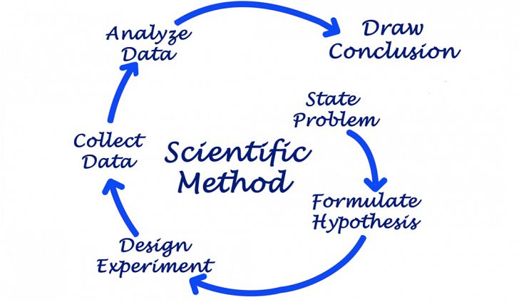

Step 1: Your Question
A hypothesis is just an educated guess about what the answer to your question will be. For example, a hypothesis to the question “Why does my dog’s tongue hang out when it’s hot?” might be “My dog’s tongue hangs out because he is thirsty.” This may or may not prove to be correct, but it’s a good guess based on the background research you’ve done, and a good place to start your project.

Step 2: Design Your Project
Whether your educated guess on what the correct answer is, in fact, correct is irrelevant. A correct hypothesis is NOT a part of the scientific method. In fact, a great many discoveries are made when scientists were NOT right in their question. Allow time to repeat your experiments to gather more data (information about your experiments) if needed.

Step 3: Organize Your Data
Use charts, graphs, pictures, but be sure to outline your process clearly and concisely – people admiring your poster should be able to tell exactly what you did without you having to explain it.

Step 4: What Did You Learn?
This is the “conclusion” of your project – was your hypothesis correct? Was it incorrect? Why or why not? Or maybe you don’t know why, and that’s ok too. Science is not always right and wrong, that’s what makes it awesome. But be sure to explain why you think you’re right or wrong. Use your data to back up your answer.

Step 5: Where Else Can This Question Go?
Many times during a science project, you come up with even more questions. A simple question can lead to 100 more questions, and further research must be done to answer these questions. This is a natural part of the scientific process! So be sure to let your audience know if there’s more discovering to be done in relation to your question.

The Engineering Design Process
The main purpose of engineering is to design and build a prototype to have it perform by solving a problem, improving a situation, or to use it in a way where a task is easier to do.

The Engineering Design Process could be used for the following projects:

What can you do with….?
- Balance
- floating in water
- periscopes
- wind power
- musical instruments
- renewable energy
- water flow
- weather instruments
- batteries
- rubber bands power mechanical power
- magnet power pulleys
- laws of motion things that float evaporation solar power balancing
- cold
- simple machines electricity power gears
- solar ovens
- airplanes chemical change hot air
- insulation
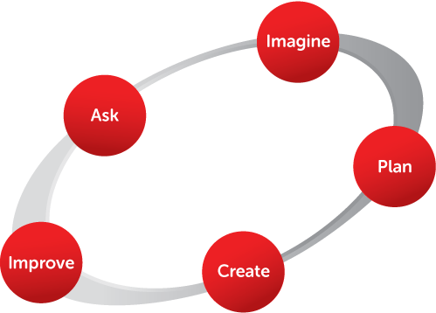

Step 1: Ask
Questions, questions, questions! There are so many questions out there concerning STEM topics. Figure out which questions you are interested in finding out the answer to: What is the problem? How have others approached it? What are your constraints?

Step 2: Imagine
Are you creative? Do your parents tell you that you have an “active imagination”? Well here’s the chance to put your brainpower to work and prove them right. What are some solutions? Brainstorm ideas. Choose the best one.

Step 3: Plan
“Failing to plan is planning to fail”! Draw a diagram of what you want your presentation to look like or do. Use a pencil so you can change your mind and go in different directions. Make lists of materials you will need.

Step 4: Create
Follow your plan and create something. Test it out! Here’s where you can get creative juices flowing. What will your presentation consist of? Will it be written down, on video or live action and interactive? It’s totally up to you!

Step 5: Improve
What works? What doesn't? What could work better? Modify your design to make it better. Test it out.

The Computer Design Process
The main purpose of the computer design process is to program a computer for people to learn about new ideas, learning how to do something, finding information that they want to know, or for the computer to perform a useful function.

The Computer Design Process could be used for the following projects:

What can you do with....?
- Finding information about a subject.
- Helping learn math concepts.
- Helping with science concepts.
- Helping with memory.
- Helping with problem solving.
- Learning new information.
- Helping learn through a learning process.
- Helping with learning about art, dance, drama, etc.
- Making something work for a useful function.
- Anything you can think of that is needed to help people out.

Step 1: Define a Need
Define a need for the program you want to code into a compute as to what you want the program to do.

Step 2: Research
Research your idea to learn about your content and what you need to know to program a computer.

Step 3: Program
Program your computer with the chosen code.

Step 4: Test
Test your many times, and analyze your results to see if it follows the criteria and constraints.

Step 5: Redesign
If needed, follow up with redesigning followed with more retesting, recording, and analyzing. *Keep doing this until you are satisfied that the performance meets the criteria and constraints. Testing could be done not only by you but by others.

Step 6: Conclusion
Show a strong conclusion of what you found out about developing and using the program.

Rules and Regulations: Safety First! Safety First! Safety First!
- No projects may be started without adult approval or conducted without adult supervision.
- Wear any protective gear that may be necessary for your project – safety goggles, gloves, aprons, etc.
- Experiments that may harm or distress people or animals are not permitted. Period.
- Experiments that involve the participation of others IS permitted, however, they must be told you are doing a science experiment and you must request their permission to use their involvement in your experiment.
- No experiments that may cause violent reactions, involve firearms or explosives are permitted.
- Always wash your hands before and after doing an experiment.
- Any project that breaks the law is not permitted.
- Protect the environment and dispose of your waste appropriately.
- Research responsibly. Have your adult help you use the computer and library to research your project.
- HAVE FUN!!!

STEM Fair Rules
- Most students will work as an individual. However, partners are allowed. Partners may be 2 people, no more. Projects with more than one person registered as author will be placed in the Partnered Projects category and are not eligible for other voted categories prizes.
- Adults are encouraged to help but students MUST be able to explain their project from start to finish.
- Part of the judging criteria will be on the use of one of the three categories of project processes, so make sure your project follows those guidelines.
- Due to time and space constraints, we cannot have students performing the experiments at the judging, or have materials beyond what can be displayed on your selected presentation type allowed.
- Size matters! Please keep your display to no larger than a typical poster board (36” x 48” for a tri-fold poster board). You do not have to use a poster board, however the size may not exceed 36” x 48”. If you use a poster board, you may mount things to your board in a 3-D type fashion but please remember your board must stand by itself. No food may be mounted! We need room for others at the tables. Example on next page:
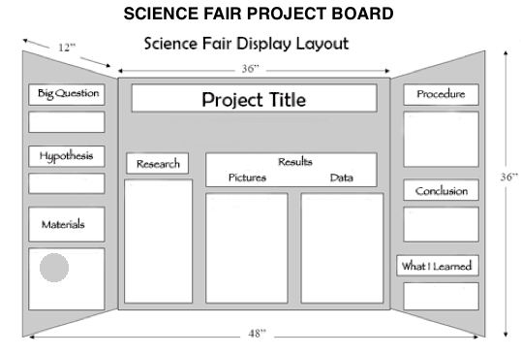
In previous years, tri-fold boards were exclusively used as exhibits. This year, you can choose to use any of the following, as long as size restrictions are still followed:
- Posters or tri-fold boards
- Prototypes, inventions, or models
- Digital presentations or videos
- Coding platforms, such as Scratch
NOTE: If your presentation requires the use of a laptop or other electronic device, you are responsible for providing the device. No electrical outlets will be available, so all devices must be sufficiently charged. The STEM Fair operates under the Portable Electronic Devices 6-15 Policy. Please see below for details:

Liability: Carroll County Public Schools assumes no responsibility for the loss, damage, theft, or charging of personally owned portable electronic devices and/or related accessories brought to school. Students bring these devices to Carroll County Public Schools at their own risk.

Misuse: Disciplinary action, as outlined in the Carroll County Public Schools Student Handbook, shall be taken when a student fails to follow the directions of a staff member regarding portable electronic devices or if reasonable belief exists that the student has violated the terms of the Acceptable Use Procedures and Guidelines or other school policy.

- Expect to have about 5-6 minutes with the judges to explain your project and answer any questions they might have. You will be interviewed during the judging, know these things:
- Information you have read about.
- All the things you did while following the Scientific Discovery, Engineering Design or Computer Design Process.
- What you learned from your project.
- How the project has helped you better understanding the world around you.
- Other questions you now have.
- What you would change next time if you did the project again.

- All decisions made by the judges are final.

STEM Fair Registration and Fair Day Information

How to Register for the Fair
- Fill out the registration form sent home from school and submit it to your teacher. He/she will collect the forms and provide them to the Chair for registration.
- Extra forms may be printed out from the PTO website (http://www.maesparrspto.com/) but please submit them through your teacher as above.
- All entries must be submitted by April 10, 2019. Please get your entries in on time – we make plans for prizes, table arrangements and food based on registration numbers. Also please let the Chair know if at any time your child can no longer attend as planned.

On the Day of the Fair
- All contestants should plan to set up their exhibit for the fair between
5:30-6 pm. The STEM Fair officially begins judging at 6 pm (all projects should be registered and ready for judging).
  - When students arrive at the Fair, they should go to the front table to check in. There they will receive a table number and an assigned time slot during the Fair in which they must be available to discuss their project with the judges. They are otherwise encouraged to mingle, participate in some of the other activities planned, and observe other student submissions, but they must be standing by their projects for discussion and/or questions during the time assigned to them.
  - Judging will begin promptly at 6 pm and conclude no later than 8 pm. All students will be awarded their ribbons (see below) during the fair; students wishing to see/keep their score sheets may get them from the registration table at the end of the Fair.
  - Category results and prizes will be awarded at the end of the Fair or during the school day, at a time to be determined.
- As in previous years, the “Danish” judging system will be used. In Danish judging, the judges do not judge one person’s work by comparing it to another’s, but student work is evaluated against a standard (see judging rubric on pages 13-15). A judge will look to see whether requirements are met. If the work meets high standards, it receives an excellent rating and blue ribbon (score of 14-16). A red ribbon signifies very good work, (score of 11-13). Yellow ribbons are given for work of good quality that will benefit from further improvements (score of 10 or below). All students will receive a ribbon and (if they choose) their evaluation sheet with the judge’s feedback. If all entries are judged to be excellent, all receive blue ribbons.
  - The purpose of using the Danish judging system is to give every student the recognition deserved for the work that was done. It also helps young people recognize the need to improve their skills.
- Judging will be organized in the following fashion:
  - Judges will be circulating the Fair with a guideline of previously determined judging criteria. Judging rubrics have been designed based on age.
  - Judges will be grouped as best as volunteerism allows in order to provide fair feedback to students. Ideally, more than one judge will give feedback to students.
  - Projects will be judged using one of three rubrics (see pages 13-15) based on the presenters age group (K-1st grade, 2nd-3rd and 4th-5th).
  - As stated previously, all students will receive a ribbon based on their score and feedback from the judges.
  - Partnered Projects Category will award ribbons to both individuals participating in the project.
- Scoring: Judges will be looking to see if your project and experiment followed the criteria set forth in the rubrics (see pages 13-15). Rubrics will be filled out and returned for tallying, and ribbons distributed accordingly.
- You must be present with a parent/guardian in order to be judged
- Students and parents are strongly encouraged to stay through the entire Fair. Games and activities relating to STEM will be taking place throughout the Fair.
- Students are asked to clean up their table prior to leaving; any projects left behind will sadly have to go in the trash!

That’s it! You now have all the tools and knowledge to go forth and make a STEM Project! Keep in mind all the information above, and you’ll do just fine. Most importantly, have FUN!

Can’t wait to see you at the STEM Fair!
Got Questions?

STEM Fair Chair and Contact Information
- MAES/Parr’s PTO maesparrspto@gmail.com

Additional Resources

Need some help coming up with an idea? Try these resources:
- Science Buddies: http://www.sciencebuddies.org
- Education.com: http://education.com/science-fair/
- Science Bob: https://sciencebob.com/
- Cool Science Projects: http://cool-science-projects.com/Science-Fair-Project-Ideas.html
- Science Fair Adventure: http://www.cool-science-projects.com/Science-Fair-Project-Ideas.html
- The Science Club: http://amasci.com/sc/
- Your Local Library!! Already have an idea? Spend some time at the library to further research it!
- Your teacher! If you have an idea, ask your teacher what he/she thinks – teachers are a wealth of information!

Scientist Number: | Kindergarten/1st Grade

 | Objectives | Outstanding Work | Very Good Work | Good Work | Needs Improvement
1. | Shows Knowledge of the Scientific Discovery/Engineering Design/Computer Design Process | Can explain most of the parts of the Scientific Discovery/Engineering Design/Computer Design Process with help from project display board (4) | Has some knowledge regarding Scientific Discovery/Engineering Design/Computer Design Process but needs help/prompting from judge (3) | Attempts to explain basic idea of Scientific Discovery/Engineering Design/Computer Design Process even with help (2) | Cannot explain basic ideas of Scientific Discovery/Engineering Design/Computer Design Process (1)
2. | Shows Enthusiasm for Project | Student is eager to share his/her project (4) | Student is pleasant to speak with and is willing to share information (3) | Student will provide information with prompting (2) | Student answers some of the questions posed by the judge (1)
3. | Speaks Knowledgably About the Project | Student shows understanding of the project (4) | Student knows generally about the project and offers minimal explanation (3) | Student answers some questions when asked (2) | Student has very little knowledge about the project (1)
4. | Display is Visually Appealing and Organized | Display shows data in an organized manner following basic outline provided. Items are clearly labeled. (4) | Display is neat and attractive and has limited data/pictures/tables etc. (3) | Display has major parts of the Scientific Discovery/Engineering Design/Computer Design Process and some data (2) | Display is missing major parts of the Scientific Discovery/Engineering Design/Computer Design Process and limited data (1)
. |  |  |  | TOTAL SCORE
Comments:

Scientist Number: | 2nd/3rd Grades

 | Objectives | Outstanding Work | Very Good Work | Good Work | Needs Improvement
1. | Shows Knowledge of the Scientific Discovery/Engineering Design/Computer Design Process | Can explain at least 80% of the Scientific Discovery/Engineering Design/Computer Design Process with understanding (4) | Can explain most of the parts of the Scientific Discovery/Engineering Design/Computer Design Process with help from project display (3) | Attempts to answer questions regarding the Scientific Discovery/ Engineering Design/ Computer Design Process but needs help/prompting from judge (2) | Cannot explain basic idea of the Scientific Discovery/Engineering Design/Computer Design Process even with help (1)
2. | Shows Enthusiasm for Project | Student is eager to share his/her project (4) | Student is pleasant to speak with and is willing to share information (3) | Student will provide information with prompting (2) | Student answers some of the questions posed by the judge (1)
3. | Speaks Knowledgably About the Project | Student shows understanding of the project (4) | Student knows generally about the project and offers minimal explanation (3) | Student answers some questions when asked (2) | Student has very little knowledge about the project (1)
4. | Display is Visually Appealing and Organized | Display shows data in an organized manner following basic outline provided. Items are clearly labeled. (4) | Display is neat and attractive and has limited data/pictures/tables etc. (3) | Display has major parts of the Scientific Discovery/ Engineering Design/ Computer Design Process and some data (2) | Display is missing major parts of the Scientific Discovery/Engineering Design/Computer Design Process and limited data. (1)
. |  |  |  | TOTAL SCORE
Comments:

Scientist Number: | 4th/5th Grades

 | Objectives | Outstanding Work | Very Good Work | Good Work |  | Needs Improvement
1. | Shows Knowledge of the Scientific Discovery/Engineering Design/Computer Design Process | Can explain all parts of the Scientific Discovery/ Engineering Design/ Computer Design Process with understanding (4) | Can explain 80% of the parts of the Scientific Discovery/Engineering Design/Computer Design Process with understanding (3) | Can explain most of the parts of the Scientific Discovery/Engineering Design/Computer Design Process with help from project display board (2) |  | Attempts to answer questions regarding the Scientific Discovery/ Engineering Design/ Computer Design Process but needs help/prompting from judge (1)
2. | Shows Enthusiasm for Project | Student is eager to share his/her project (4) | Student is pleasant to speak with and is willing to share information (3) | Student will provide information with prompting (2) |  | Student answers some of the questions posed by the judge (1)
3. | Speaks Knowledgably About the Project | Student is able to share many details about his/her project through the Scientific Discovery/ Engineering Design/ Computer Design Process (4) | Student shows understanding of the project (3) | Student knows generally about the project and offers minimal explanation (2) |  | Student answers some questions when asked (1)
4. | Display is Visually Appealing and Organized | Display shows data in an organized manner following basic outline provided. Items are clearly labeled. (4) | Display is neat and attractive and has limited data/pictures/tables etc. (3) | Display has major parts of the Scientific Discovery/ Engineering Design/ Computer Design Process and some data (2) |  | Display is missing major parts of the Scientific Discovery/Engineering Design/Computer Design Process and limited data (1)
. |  |  |  |  | TOTAL SCORE

